 | 12.1.18 Editors - Geometry Nodes Editor - Header - Add Menu - Curve - Read
Table of content
Detailed table of content 1
Add - Curve - Read 3
Curve Handle Positions 3
Cuve Length 3
Curve Tangent 4
Curve Tilt 4
Endpoint Selection 4
Handle Type Selection 5
Is Spline Cyclic 5
Spline Length 5
Spline Parameter 6
Spline Resolution 6

Detailed table of content
Detailed table of content
Detailed table of content 1
Add - Curve - Read 3
Curve Handle Positions 3
Outputs 3
Left 3
Right 3
Cuve Length 3
Inputs 3
Curve 3
Outputs 3
Length 3
Curve Tangent 4
Outputs 4
Factor 4
Curve Tilt 4
Outputs 4
Tilt 4
Endpoint Selection 4
Input 4
Start Size 4
End Size 4
Outputs 5
Selection 5
Handle Type Selection 5
Properties 5
Left / Right 5
Handle Type 5
Output 5
Selection 5
Is Spline Cyclic 5
Outputs 5
Cyclic 5
Spline Length 5
Outputs 5
Length 5
Point Count 6
Spline Parameter 6
Outputs 6
Factor 6
Length 6
Index 6
Spline Resolution 6
Outputs 7
Resolution 7

Add - Curve - Read
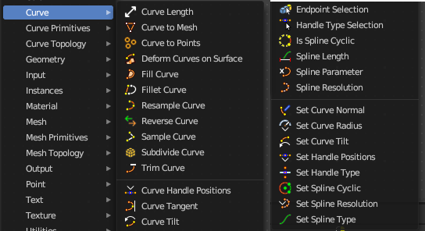
Here you find curve related nodes.

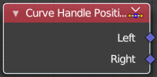
Curve Handle Positions
Get the position of the left or right handle of a curve point.

Outputs

Left
The left handle of the curve point.

Right
The right handle of the curve point.

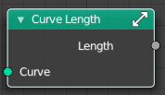
Cuve Length
Retreives the length of all splines added together.

Inputs

Curve
The input curve.

Outputs

Length
The length of the curve.

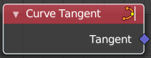
Curve Tangent
Retreive the tangent direction of a curve. The output values are normalized vectors.
Note that for NURBS and Bézier spline curves the value retrieved from this node is the value at every control point, which may not correspond to the visible evaluated points. For NURBS splines the difference may be even more pronounced and the result may not be as expected. A Resample Curve Node node can be used to create a poly spline, where there is a control point for every evaluated point.

Outputs

Factor
The vector of the tangent.

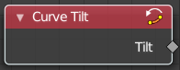
Curve Tilt
Outputs the angle used to turn the curve normal around the direction of the curve tangent in its evaluated points.
The output is per control point. For NURBS and Bézier splines, the values will be interpolated to the final evaluated points.

Outputs

Tilt
The tilt angle for the normal in radians.

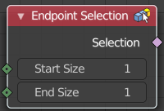
Endpoint Selection
The Endpoint Selection node allows for the Selection of an aribitrary
number of endpoints from each spline in a curve. The start and end
inputs are evaluated on the spline domain. The result is outputted
as a boolean field on the point domain.

Input

Start Size
The start point of the spline.

End Size
The end point of the spline.

Outputs

Selection
Selection output.

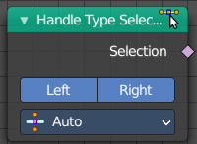
Handle Type Selection
Creates a selection based on the handle types of the control points.

Properties

Left / Right
Wether to check for the type of handles.

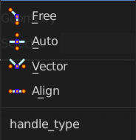
Handle Type
What handle type to compare.

Output

Selection
The selection.

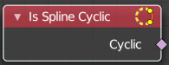
Is Spline Cyclic
Retreive if the curve is set to cyclic.

Outputs

Cyclic
If the spline is cyclic or not.

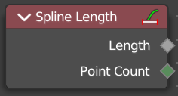
Spline Length
Retreive the total length of each spline in a curve.

Outputs

Length
The length of each spline in the curve.

Point Count
Integer Field input of the number of control points on each spline in the spline domain. Or in the point domain, it is the number of points on the spline that contains the given control point.

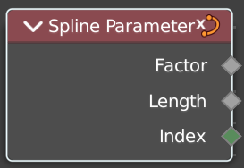
Spline Parameter
The Curve Parameter node outputs how far along each spline a control point is, with a value between zero and one. The output is different from dividing the index by the total number of control points, because the control points might not be equally spaced along the curve.
The first value is zero, so the output corresponds to the length at the control point rather than including the length of the following segment.

When used on the spline domain, the node outputs the portion of the total length of the curve (including all splines) has been traversed at the start of each spline. The order of the curve’s splines is visible in the Spreadsheet Editor.
Note that for NURBS and Bézier spline curves the value retrieved from this node is the value at every control point, which may not correspond to the visible evaluated points. For NURBS splines the difference may be even more pronounced and the result may not be as expected. A Resample Curve Node node can be used to create a poly spline, where there is a control point for every evaluated point.

Outputs

Factor
The factor of the curve.

Length
The length of the curve.

Index
The index of the curve.

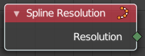
Spline Resolution
Retreive the curve resolution. Means the number of spline points.

Outputs

Resolution
The spline resolution.

